Grade 3
Tetrominoes and Monomino Patterns

Description: | Students will:  Make a set of tetrominoes.  Use a playfield grid.  Decide the size of playfield and the scale of its grid.  Analyze how many shapes can be made of four connected dots with centers on horizontal or vertical lines.  Create each four piece shape as an object.  Discover and apply patterns of menu options.
Project View | 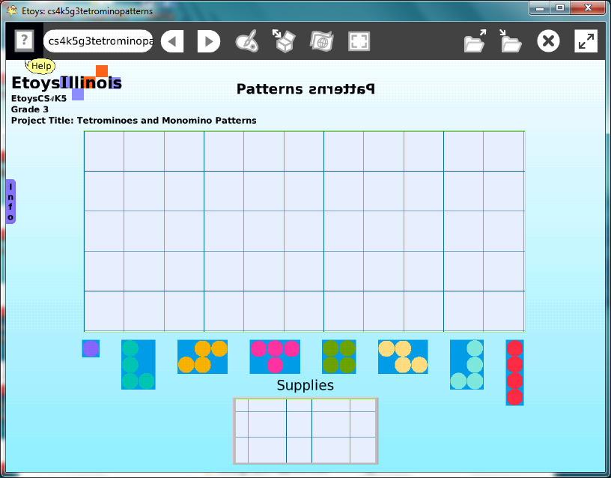
Subject: | Math, Art
Etoys Quick Guides | Click the question mark in Etoys to open the set of interactive tutorials for basic tools and techniques.
Vocabulary: | Area, perimeter, paving, tiling, patterns, visual patterns, word patterns, menu patterns, symmetry, similar, exact, almost, nearly, precise, observe, analyze, experiment, tetra, Tetromino, Tetrominoes, grid, array, scale, slide, rotate, rotation, turn, reflection, mirror image
Lesson 1:  Paint Tools: Brushes  Menu: Playfield Graph Paper Options  Halo Handles: Menu Tools  Navigator Bar: Keep Find Projects | Give students four pennies and a piece of graph paper and ask how many different shapes are possible when the pennies must touch and their centers must be on horizontal and vertical lines. Represented by letters that are similar in shape, the seven Tetrominoes are: L, J, T, S, Z, I, and O. Read brief info at: http://en.wikipedia.org/wiki/Tetromino  Open a paint palette and paint the shapes. Keep the shapes as one object as a reference for the next part of the lesson.  Get a playfield from Supplies. Open its Viewer and click on the white menu. Chose make graph paper.  A dialog box opens asking what size the grid should be. A second dialog box asks what color background should be and a third dialog box asks what color the lines should be. Give students time to experiment with different grid sizes and color combinations. They should see that the larger the grid size, the fewer squares there will be when the area of the playfield stays the same. Students should decide how large the grid will be for their pattern pieces and how large the playfield should be for the pattern constructions.  Open the Halo of handles for the playfield grid and choose the white menu and use the push pin to keep the menu open. Select drop shadow and experiment with color and offset choices.  When students have chosen the size and color of the grid open a paint palette and chose a brush size that will fit the size grid they selected. The grid is visible under the paint scrim. Paint brushes will make consistent sized dots of color and are probably easier to control that the ones made by the ellipse tool.  Draw each pattern piece with a new paint palette and keep each so each can be picked up and moved separately. Paint one single dot, called a monomino, to use when making the patterns. Discard the reference version of the pieces after all the separate ones are made.  Give students time to see other projects and experiment with different grid sizes and color schemes and to edit their project choices.  This example project uses a 5x11 grid and will always have one empty square. A single dot, the monomino, was added to the project to give more design and pattern options. The grid could have been a 4x10 or 2x20 or any other combinations that make an even number of grid squares. All are good options and something students enjoy trying.  Keep the project. NameTetPattern
Lesson 2:  Object Catalog: Maker Buttons  Script Tiles: Scale Factor | This lesson adds maker buttons and asks students to begin to develop an understanding of the patterns of choices for color properties of objects.  Open Supplies, get an Object Catalog and chose the Connectors tab.  Get two Maker Buttons. These will be used as the supply of maker buttons and to supply the pattern pieces.  Open a Halo for one of the Maker Buttons, click on the magenta color picker and choose a color. Put that Maker Button on the other Maker Button. This will supply all the maker buttons for the project, click and drag off copies of the maker button as needed.  Put the Tetrominoes and the Monomino on Maker Buttons. Put the Playfield grid on one too. Discard the Maker Button that has been used as a supply of them.  The pattern pieces on Maker Buttons may be too large for the screen. Open a Viewer for each maker button, click on basic to open a menu and choose the Geometry category. Change the scale factor by clicking on the small up/down green arrows or by typing in a new value. Give students time to understand how using the numbers gives them control over size and to make the changes uniform.  Fill and border are menu choices for objects that are part of the standard supplies and environment of Etoys. Fill and border are limited for objects painted using the paint tools.  Change the color of the world.  Open a viewer for the world click on Scripts to open a menu choose Fill and Border. Give students time to experiment with all four of the tiles in this set. The tiles do not need to be dragged out to form scripts.  Keep the project.
Lesson 3:  Supplies: Add a New Flap  Script Tiles: X and Y Tiles  Supplies: Text | Make a flap for the project information and directions.  Click on My Flap in Supplies. Open a halo for the Flap click the white menu. Click the push pin to keep the menu open.  Follow the dialog boxes to decide the title and location of the flap.  Click the new flap’s tab to open it. The flap’s size can be adjusted by dragging it and then clicking the tab to shut it again, like a window shade.  Change the color of the tab: use its white menu.  Change the color of the flap: use its white menu.  Suggest that students use x and y coordinates to precisely locate the Maker Buttons on their screen.  Get Text from Supplies and type directions for the project.  Change the color of the Text: use fill and border.  Get another Text from Supplies and type a title for the project. Give students time to choose an interesting and appealing title and to position the title so it fits with the puzzle pieces and grid.  Change the color of the text: use its fill and border tiles.  Keep the project, change the name to: nameTetPatFinal
Lesson 4:  Object Catalog: Grab Patch Tool | Give students time to make patterns, to develop understandings on how a set number of pieces can be put together in many ways. Give them time to play with their project.  Ask students to make half of a pattern and then to change places with a nearby student to complete the other half of their pattern.  Encourage students to change the size of the playfield and see what other patterns can be made with larger and smaller areas.  Students who want to keep copies of favorite patterns can use a Grab Patch tool from the Object Catalog. Copy, shrink, and store the favorites in the flap.  Keep the project each time new patterns are placed in the flap so they will accumulate as a library of design ideas.  N.B. This project is one of a set of three projects that use tetromino shapes. Students who enjoy these shapes may also like to use them in a puzzle and a game. The puzzle project is in the CS4K5 Grade 4 curriculum and the game is a CS4K5 Grade 5 project. Students who do all three projects in one year will find that they can reuse or modify shapes, flaps, grids, and other objects.
Standards: | Common Core Standards  Mathematics: 3.NF.1.3.a; 3.MD.3.a.4. 5.6.7.8  Bloom’s Taxonomy/Cognitive Domain:  Knowledge: knows, defines  Comprehension: classifies  Analysis: experiments  Evaluation: compares, investigates  NETS  1. a  2. a  4. a, b  6. a, b
Resources: | Etoys Help Quick Guides: always available in Etoys. Open Etoys and click the question mark to open a set of interactive tutorials of basic tools and techniques.  www.etoysillinois.org projects, lesson plans, software download  www.mste.Illinois.org more math, science, and technology resources  www.corestandards.org Common Core Standards  www.squeakland.org software and Etoys projects  www.nctm.org Standards and Focal Points for each grade level
kh January 2011

